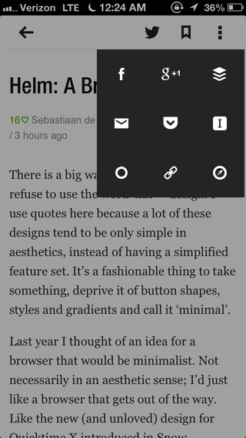
pttrns.com - jukely app overview

Like the pop up icon menu and dimmed background. Not sure why it's over to the right, would maybe put it in the middle of the screen since it is the most important thing that's popping up.
Would probably also use clors for the icons - a bit too much black and white.

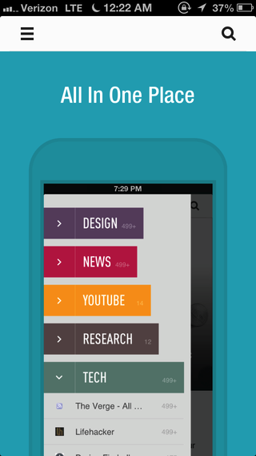

Colors and vertical tabbed view.

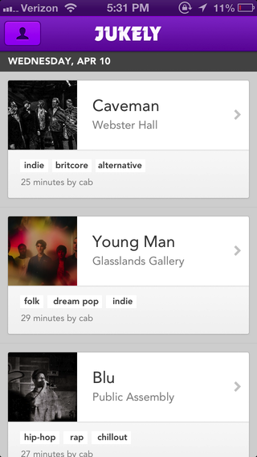

Like the categorization of information. How could that work with tours?
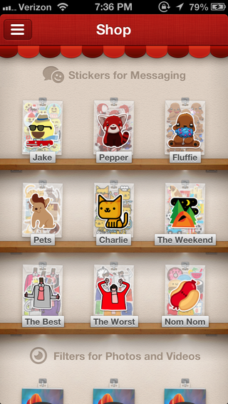

Like the display of information.
Could display collection of tours people could take, and when you'd clidk on one, a pop up box would come up, background would dim. Pop up would display title image, and a tag line?

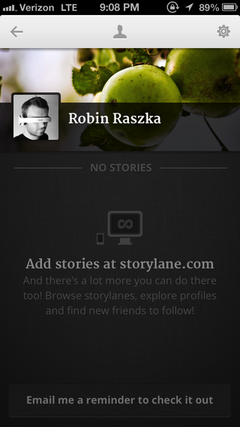
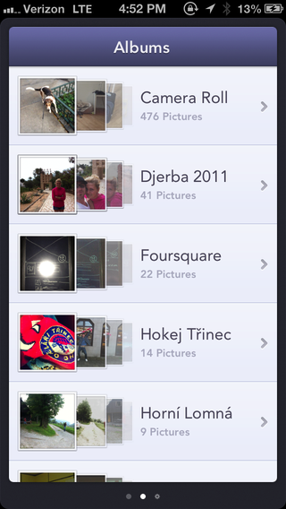
Like the minimal layout.
seems too cluttered, visually.

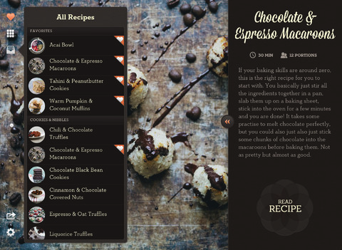
LOVELY UI .COM
LIKE THIS LAYOUT, and maybe the idea of a retractable menu -

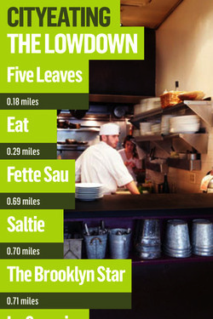

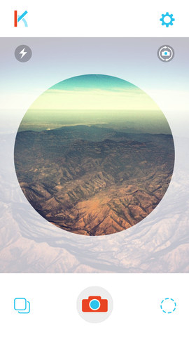
Really like the idea of the circle
Could the circle be a way of displaying the title, with a signature image in the back? Title overlayed in the middle.

